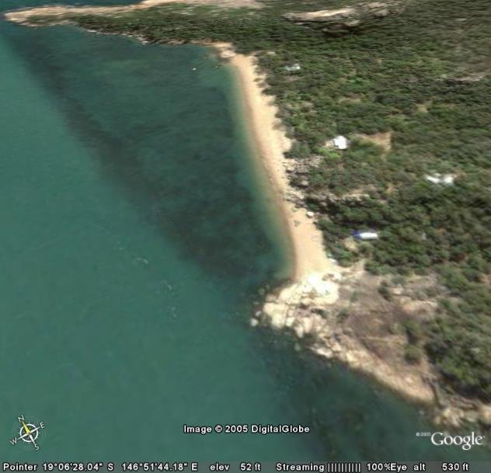
DMAC – Ecotourism Plan for White Lady Bay
Ocean nursery
Seawater intake
Hatchery / nursery
Staff qtrs.
Art Stall & Ecotour start point
track
Boat entry

Conceptualized by Dr. R.D. Braley (7 January 2012)

